## Conditional Statements

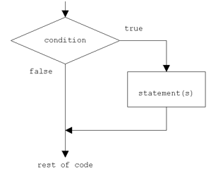

In Python, if statement evaluates the test expression inside parenthesis. If test expression is evaluated to true (nonzero) , statements inside the body of if is executed. If test expression is evaluated to false (0) , statements inside the body of if is skipped.

## Python if..else statements

The else statement is to specify a block of code to be executed, if the condition in the if statement is false. Thus, the else clause ensures that a sequence of statements is executed.

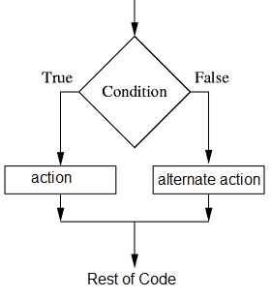

## Nested If Statements

Nested if statements are an if statement inside another if statement.

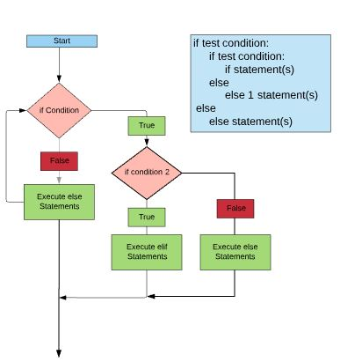

## Repetition

A **repetition statement** is used to repeat a group(block) of programming instructions.

In Python, we generally have two loops/repetitive statements:

for loop

while loop

**for loop:** A for loop is used to iterate over a sequence that is either a list, tuple, dictionary, or a set. We can execute a set of statements once for each item in a list, tuple, or dictionary.

**while loop:** In Python, *while loops* are used to execute a block of statements repeatedly until a given condition is satisfied. Then, the expression is checked again and, if it is still true, the body is executed again. This continues until the expression becomes false.

